**DAILY ONLINE ACTIVITIES SUMMARY**

|  |  |  |  |  |  |  |  |  |
| --- | --- | --- | --- | --- | --- | --- | --- | --- |
| **Date:** | **11-06-2020** | | | | | **Name:** | **Nihal Rafiq** | |
| **Sem & Sec** | **4th A** | | | | | **USN:** | **4AL18CS052** | |
| **Online Test Summary** | | | | | | | | |
| **Subject** | | **---** | | | | | | |
| **Max. Marks** | | **---** | | **Score** | | | **---** | |
| **Certification Course Summary** | | | | | | | | |
| **Course** | **Data Visualization using Python** | | | | | | | |
| **Certificate Provider** | | | **Great Learning Academy** | | **Duration** | | | **2 hours** |
| **Coding Challenges** | | | | | | | | |
| **Problem Statement:**  **1. Write a java program to segregate even and odd numbers** | | | | | | | | |
| **Status: Executed** | | | | | | | | |
| **Uploaded the report in Github** | | | | | **Yes** | | | |
| **If yes Repository name** | | | | | **https://github.com/nihal-art/lockdown-coding** | | | |
| **Uploaded the report in slack** | | | | | **Yes** | | | |

Certification Course Details:

I have opted for Data Visualization using Python.

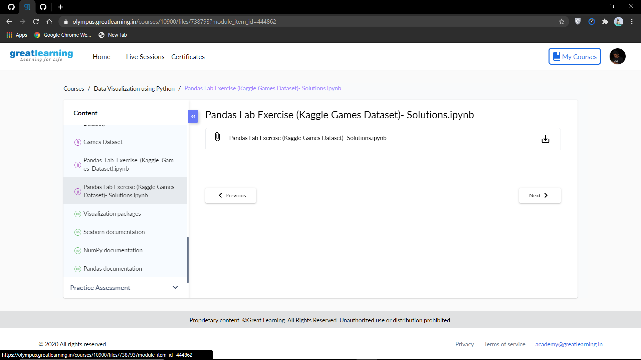

Coding Challenges Details:

1. Write a java program to segregate even and odd numbers. Given an array A [], write a function that segregate even and odd numbers. The functions should put all even numbers first, and then odd numbers

Example: input= (12,34,45,9,8,90,3) output= (12,34,8,90,45,9,3)

